**ENHANCEMENT IN THE BIOGAS PRODUCTION EFFICIENCY BY INCORPORATING A BIO-ELECTROCHEMICAL SYSTEM USING KITCHEN WASTE AS A FEEDSTOCK**

**A Dissertation Submitted for the Partial Fulfillment of the Requirements for Master of Science Degree in Chemistry**



**Submitted by:**

**Sushmita Thapa**

**Exam Symbol No. / Year: CHE 1769/076**

**T.U. Registration No.: 5-2-37-1654-2015**

**Submitted to:**

**Central Department of Chemistry**

**Institute of Science and Technology**

**Tribhuvan University**

**Kirtipur, Kathmandu**

**Nepal**

**October, 2023**

**BOARD EXAMINER AND CERTIFICATE OF APPROVAL**

This dissertation entitled “Enhancement in the biogas production efficiency by incorporating bio-electrochemical system using kitchen waste as a feedstock” by Miss Sushmita Thapa under the supervision of Prof. Dr. Amar Prasad Yadav, Central Department of Chemistry, Tribhuvan University Nepal is hereby submitted for the partial fulfillment of the master of Science (M.Sc.) Degree in Chemistry. This dissertation has not been submitted to any other university or institution previously for the award of a degree.

Supervisor:

Prof. Dr. Amar Prasad Yadav

Central Department of Chemistry

Tribhuvan University

Kathmandu, Nepal

**RECOMMENDATION LETTER**

This is to certify that the dissertation work entitled “Enhancement in the biogas production efficiency by incorporating bio-electrochemical system using kitchen waste as a feedstock” has been carried out by Miss Sushmita Thapa as partial fulfillment for the requirement of M.SC. Degree in Chemistry under my supervision. To the best of my knowledge, this work has not been submitted to any other degree in this institute.

Supervisor:

Prof. Dr. Amar Prasad Yadav

Central Department of Chemistry

Tribhuvan University

Kathmandu, Nepal

**DECLARATION**

I, Sushmita Thapa hereby declare that the work presented herein is genuine work done originally by me and has not been published or submitted elsewhere for the requirement of a degree program. Any literature data or works done by others and cited in this dissertation have been given due acknowledgment and listed in the reference section.

Sushmita Thapa

Central Department of Chemistry

Tribhuvan University Kiritipur

Kathmandu, Nepal

**ACKNOWLEDGEMENTS**

I would like to express my deepest and sincere gratitude to my respected supervisor Prof. Dr. Amar Prasad Yadav, Central Department of Chemistry, Tribhuvan University for his constructive guidance continuous support, encouragement, and suggestions in the execution of this dissertation and moreover for the inspiration he provided to me made this work to reach fruitful destination.

I am very much grateful to Prof. Dr. Jagadish Bhattrai, Head of Department, Central Department of Chemistry, Tribhuvan University for providing me with an opportunity to carry out this dissertation.

I would like to express my deepest sense of gratitude and sincere thanks to all the professors and laboratory staff of the Central Department of Chemistry for their worthwhile assistance during my laboratory work at CDC.

I am equally grateful the National Priority Research Project, Research Coordination and Development Council (RCDC), Tribhuvan University for providing the grant for the experiment. Without this, the project would have been impossible.

My warm admiration also goes to all my friends brothers and sisters working in the central department of chemistry for their kind help during the lab work. Also, I would like to acknowledge my seniors for their collaboration throughout this work.

I express my profound gratitude to my family for always being there in need. This thesis would have been completed without their support. Last but not least, I would like to thank every supportive hand that has not been mentioned by name but has given invaluable help in their own way directly or indirectly during this study.

Sushmita Thapa

**LIST OF ACRONYMS**

COD Chemical Oxygen Demand

AD Anaerobic digestion

HCL Hydrochloric acid

MEC Microbial Electrolysis Cell

KW Kitchen Waste

FW Food waste

PM Poultry manure

CO2 Carbondioxide

Mg Milligram

LPG Liquified Petroleum Gas

CBG Cumulative Biogas

OC Organic Compounds

TVS Total Volatile Solids

TCOD Total Chemical Oxygen Demand

HRT Hrdraulic Retention Time

˚C Degree Celsius

VFA Volatile Fatty Acids

**ABSTRACT**

To meet the growing demand for non-renewable sources of energy and to create a sustainable and eco-friendly environment, there is a need to shift nonrenewable fossil fuel energy to a renewable source of energy. Microbial electrolysis synthesis (MES) is emerging as a novel technology that is able to convert soluble organic matter into energy such as hydrogen gas. Anaerobic digestion is a traditional method of producing methane-containing biogas by utilizing the methanogenic conversion of organic matter. Recently, the application of MES technology to a traditional anaerobic digestion system has been extensively studied to find new opportunities in increasing the methane yield. To increase the methane content of the biogas plants, an anaerobic process is used where acetate-utilizing methanogens dominate the methane production process whereas H2/CO2 utilizing methanogens are often limited due to the restricted availability of hydrogen or other electron donors. Due to this a large amount of CO2 remained in the biogas as waste. So, this research aims to incorporate bio-electrochemical systems for an enhanced conversion of generated CO2 to CH4 using electrical energy as a driving force in the presence of methanogens. This process is called Electromethanogenesis. With the introduction of electromethanogenesis in anaerobic digestion, CO2 will be removed and CH4 will be increased in biogas.

In this study, the test vessel, which received electricity, and the control vessel, which did not receive power, were employed. The fact that MES is an alternative approach for increasing biogas production is supported by the finding that the gas output was higher in the test tank than in the control vessel in every instance. It was found that the total amount of gas generated in the test vessel was 566 ml, compared to 187 ml in the control vessel for 10 % dilution. For 20 %, 30 %, and 50 %, the cumulative gas formed in the test vessel was 412 ml, 506 ml, and 496 ml respectively. Similarly, the gas accumulated in the control vessels was found to be 198 ml, 266 ml, and 302 ml for 20%, 30 %, and 50 % respectively. 10 % dilution was shown to be more effective for producing biogas during the sequence of solutions used in the experiment. Consequently, MES is found to be a successful technology for upgrading biogas.

Keywords: Biogas, Microbial electrolysis synthesis, Electromethanogenesis, Anaerobic digestion

**CHAPTER 1: INTRODUCTION**

* 1. **Background**

In the atmosphere, carbon dioxide is abundant by nature (approximately 0.03-0.04%) and ultimately responsible for regulating the biological equilibrium of the biosphere. Nevertheless, as the population expands and the demand for energy rises the naturally occurring cycles of greenhouse gases for instance CO2 have undergone modifications. Concerns about the environment brought on by the release of greenhouse gases from the combustion of fossil fuels have resulted in a paradigm shift in commercial business approaches which has led to the invention of new configuration systems for waste management and the production of bioenergy.

A solution to the growing accumulation of waste and energy dilemma can be found in the energy extraction from kitchen debris. Waste-based bioenergy production has drawn much attention and offered an alternative perspective on utilizing renewable energy sources. Consequently, the development of microbial fuel cells has become extensively recognized as a promising method to produce energy. Due to the lack of a separate pre-treatment step, the generation of biogas from kitchen wastes may serve as an innovative method for producing bioelectricity and help facilitate the handling of solid garbage as well.

The most typical kind of recyclable waste in every household comprises kitchen waste. Using microbial fuel cell technology for the degradation of garbage can be a lucrative and environmentally friendly approach to address solid kitchen wastes and produce alternative energy.

Kitchen waste can be properly disposed of by employing anaerobic fermentation (AF) without the drawbacks of conventional techniques like incineration and sanitary dumping of waste. Since kitchen waste has a significant amount of organic materials it effortlessly induces acidification and ammonia inhibition during digestion. Kitchen waste frequently undergoes disposal via sanitary landfills anaerobic composting purposes and feed treatment. Unfortunately due to kitchen waste's intricacy, these remedies have numerous drawbacks. Numerous issues particularly the emission of hazardous pollutants groundwater contamination and deterioration of the soil can be brought on by sanitary landfills (Zhu and Cheng et al., 2023).

AF may compensate for the shortcomings of conventional techniques by yielding substantial amounts of biogas while also effectively minimizing the discharge of hazardous gases. Different varieties of KW have been successfully treated with a technology. An anaerobic microbe's ability to transform organic matter into a stable product gained popularity. AF is a complicated procedure in which methane hydrogen and other different kinds of sustainable bioenergy are produced from organic materials by a variety of bacteria and methanogenic archaea (Zhu and Cheng et al., 2023). Due to its high biodegradability calorific value and nutritional value to microbes, KW can be reused to generate biogas lowering our reliance on fossil fuels.

**1.2: Anaerobic digestion:**

Anaerobic digestion (AD) is a process that can produce biogas and was studied as a potential source of alternative energy. To handle a significant amount of waste it has become essential to look for sustainable environmental strategies. In an attempt to battle this global energy issue anaerobic digestion (AD) has become a technologically as well as financially viable solution.

Anaerobic digestion of organic waste yields biogas which enables the production of sustainable dependable and renewable energy. Kitchen waste has the potential to produce biogas and at the same time, the waste can be treated to mitigate its detrimental impact on the environment and develop nutrient-rich organic fertilizer.

Anaerobic bacteria take part in the anaerobic digestion process which results in the production of methane and carbon dioxide as active chemicals are broken down. Hydrolysis acidogenesis acetogenesis and methanogenesis are the four phases that make up the mechanics of the process. The breakdown of organic polymers including proteins carbohydrates and facts into soluble. Monosaccharides, amino acids, and fatty acids by bacterial enzymes are known as hydrolysis which is the initial stage. During the acidogenesis phase chemicals and hydrolysis by-products are converted to volatile fatty acids. The most crucial stage comes next and it is called as acetogenesis. In this process, volatile fatty acids are converted into acetic acid carbon dioxide, and hydrogen. The final step is methanogenesis. Methane and carbon dioxide are mostly produced in this process.

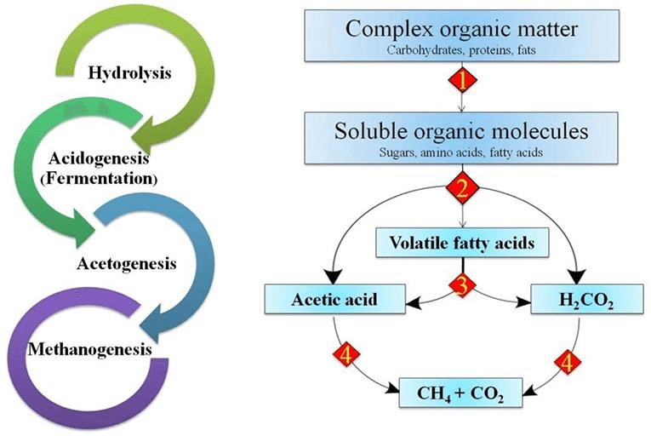

*Figure 1: Steps in anaerobic Digestion (From Dussadee et al. 2016)*

**1.3: Electromethanogenesis:**

By employing CO2 as the only carbon source in an artificial system (biocathode) powered by electric current, electroactive microorganisms create methane by electromethanogenesis. A special type of BES/ MEs called electromethanogenesis occurs when only CH4 is generated from CO2 and electricity is used to supply the additional energy required to recombine CO2 with electrons and protons (Cerillo et al. 2021). Therefore, electromethanogenesis is a subset of BES/MES, the microbial electrosynthesis of different compounds.



*Figure 2: Anaerobic digestion with electromethanogensis*

Anaerobic breakdown of organic materials will be accelerated at the microbial electrochemical cells anode as shown in the figure. The anode will combine the oxidation of sugars to organic acids and the ensuing oxidation of acids to acetate. Organic substances may degrade an additional number of times anaerobically. The system's electrons come from anode reactions. The following describes the full sugar degradation reaction at the anode.

C6H12O6 + 12H2O 🡪 6HCO3- + 30H+ + 24 e-

Anode potential E°’ = -0.41 to -0.28 V (vs standard hydrogen electrode)

At the cathode, the following reduction reaction will occur

HCO3- + 8e- + 9H+ 🡪 CH4 + 3H2O

Cathode potential E°’ = -0.24 V (vs standard hydrogen electrode)

For the electrolysis of water, the cathode reaction will be

2H+ + 2e- 🡪 H2

Cathode potential E°’ = -0.414 V (vs standard hydrogen electrode)

This hydrogen produced electrochemically will be used in the CO2 reduction by hydrogenotrophic methanogens.

4H2 + CO2 🡪 CH4 + 2H2O

**1.4: Kitchen Waste:**

Kitchen waste is defined as leftover organic matter from restaurants hotels and households. It usually involves fruits and vegetables scraps leftover foods etc.

**1.4.1: Effects of kitchen waste:**

Improper waste disposal is hazardous to human health. Apart from being unattractive, it pollutes the air harms aquatic bodies when dumped into them, and depletes the ozone layer when burned exacerbating the effects of climate change. Traditional waste management strategies are frequently ineffective (Aruna et al., 2018). Waste is burned disposed of in oceans and waterways and deposited along roadsides (Ogwueleka et al., 2009).

Wastes pollute the environment and endanger people's lives. These negative impacts affect both humans and animals and can lead to disease outbreaks reduced life expectancy and a dangerous environment. Some garbage may degrade but those that do not will stink and produce methane gas which contributes greatly to the greenhouse effects. When solid wastes are burned green greenhouse gases such as carbon dioxide and nitrous oxide are emitted causing ozone layer depletion and the greenhouse effect (Bhat et al., 2018).

**1.4.2: Methods of Kitchen waste disposal:**

**1. Disposal by open dump:**

This is a garbage disposal method in which waste is dropped indiscriminately in any available location. This form of waste disposal should be avoided. The wastes disposed of in this manner serve as the breeding ground for fly rates. They Transmit different diseases and emit an awful odor (Alam et al., 2013).

**2. Disposal by Animal Feeding:**

Wastes such as yam peal cassava peel leaves and leftover foods are fed to domestic animals such as goats, dogs, and sheep. Total wastes could get infectious infecting animals directly fed on the wastes or humans who eat on such animals (Abdel-Shafy et al., 2018).

**3. Dump by incineration:**

Here the combustible garbage is burned at high temperatures. This reduces the volume of such wastes by 90%. The byproducts of the combustion of things such as ashes glass and metals. They are then disposed of in a sanitary landfill (Alam et al., 2013)

**4. Disposal by sanitary landfills:**

This approach involves the utilization of waste in landfills. The procedure involves spreading garbage in thin layers and compressing each layer with a large bulldozer. When the garbage reaches a height of roughly 3 m, it is covered with a thin coating of clean soil and squeezed again. This procedure is repeated until the pit is filled (Alam et al., 2013). Waste disposed of in this manner may contain pathogenic microbes or toxic compounds that are detrimental to soil and soil organisms as well as humans. Because of these negative consequences, the government has discouraged this technique pushing other waste disposal methods such as anaerobic waste treatment and incineration with energy recovery (Wang et al., 2020).

**5. Disposal by composting:**

This method helps to eliminate biodegradable organic waste. It is a viable method of converting diverse organic wastes into compounds that can be utilized safely and beneficially as biofertilizers. Composting is a safe method of disposing of organic waste, however, it produces odors and emits greenhouse gases.

**1.5: Bio-electrochemical systems (BESs):**

To generate sustainable energy and achieve carbon neutrality, bio-electrochemical systems (BESs), which are developing environmental biotechnologies, use microbial interfacial electron transfer and electrochemical transformations. Comparatively, to traditional chemical and environmental processes, BESs offer an outstanding technique for the process based on metabolic oxidation and reduction (Naradasu et al., 2021). The chemical energy of organic waste, such as low-strength wastewater and lignocellulosic biomass, can be converted by BESs into electricity, hydrogen/chemical products in microbial electrolysis cells (MECs), or other products created at the cathode by an electrochemical reduction process. Compared to conventional fuel cells, BESs function under more benign circumstances, use a variety of organic substrates, and typically do not rely on pricey precious metals as catalysts. The scope for these systems has been substantially enlarged by the recently discovered usage of BES for product synthesis through microbial electrosynthesis. BESs are particularly promising technologies since they feature newer application concepts, the development of substitute materials for electrodes, separators, and catalysts, and unique designs (Pant et al., 2012).

Microorganisms are used in BESs to catalyze oxidation and reduction reactions at anodic and cathodic electrodes, respectively. In a nutshell, both organic and inorganic electron donors can undergo oxidation at an anode, the best examples of these electron donors are sulfides and waste organics. An electron acceptor, such as oxygen or nitrate can be reduced at the cathode. A circuit of electricity connects the anode with the cathode. The system is known as a microbial fuel cell (MFC) if electrical power is extracted from the circuit and a microbial electrolysis cell (MEC) if electrical power is invested in the system (Rabaey et al., 2009).

**1.5.1: Components of BES:**

The BES comprises of an anode, where oxidation occurs, and a cathode where reduction occurs. At least one of the electrodes uses microorganisms to catalyze the redox reaction either directly or through mediators by interacting with the electrode. Bioelectrode is the term used to describe the electrode and the nearby bacteria, which is typically arranged in a biofilm. A membrane can be used to divide the anode from the cathode, but it is not a necessary part of the BES (Gonczi et al., 2023).

1. **Membranes:**

Proton exchange membranes (PEMs) and ion exchange membranes (IEMs) are the two categories into which the membranes used in BES can be divided. Cation exchange membranes and anion exchange membranes are examples of IEMs. Bipolar membranes (ion exchange composite membranes), amphoteric, mosaic, and inorganic-organic membranes are some of the IEMs that have been introduced to the market (Xu.T., 2005).

1. **Electrodes:**

An important aspect of the design involves selecting the appropriate electrodes. In order to attain high efficiency, the electrodes and the microorganisms work together to create a bioelectrode (Zeppilli et al., 2019). Electrode materials can be broadly classified into three categories namely; carbon-based, metal-based, and metal-carbon composite( Guo et al., 2015).

The most stable and well-known carbon allotrope used in BES systems is graphite (Das et al., 2022). Graphite has particular advantages because of the peculiar structure of the bonds connecting the carbon atoms. It is made of graphene layers in which each carbon atom is strongly bound to three carbon atoms to form continuous hexagons. Weaker van der Waals bonds are used to join the layers. Due to its specific layered structure, graphite possesses special properties like chemical and physical stability as well as excellent thermal and electrical conductivity (Pierson et al., 1993). The most popular type of electrode for carbon-based BES materials is graphite. They are reusable and quite inexpensive. Graphite comes in a variety of commercially available forms, including rod, block, brush, plate, and sheet (Feng et al., 2018).

One of the key issues with BES is overpotential. By selecting an appropriate electrode material the surface of the electrode can be increased and the electrode's resistance can be decreased to lessen its harmful effects (Seigert et al., 2014). Due to their improved conductivity and reduced internal resistance compared to carbon-based electrodes metal-based electrodes are employed extensively. They are available as mesh, sheet, plate, wire, and other forms. Due to its inertness and low overpotential, platinum is one of the best noble metals for electrochemical systems (Sangeetha et al., 2016). Metal electrodes are less biocompatible have a higher risk of corrosion, and have a lower specific surface area than carbon-based electrodes (Dumas et al., 2007).

1. **Substrates (fuels):**

Substrates are organic compounds that the microbe consumes during catalytic or enzymatic reactions in bioelectrochemistry. It is regarded as one of the crucial biofactors influencing the production of electricity. The substrate acts as a source of carbon energy by giving the bacterial cells the energy they need to thrive. It has an impact on both the performance and economic viability. These consist of water, cellulose, and acetate as well as simple sugars like glucose, pure sugar, low molecular weight sugar, or complex sugars. Acetate is the most straightforward yet often utilized organic substrate. As a result of its resistance to fermentation and methanogenesis at room temperature among other microbial transformation temperatures (Ivase et al., 2020)

1. **Microorganisms:**

By dissolving organic substances (substrate) into various ions, which affects how electrons travel through the BES, Microorganisms play a critical role. Microorganisms are in theory, microscopic, living things with one or more cells. Archaea, bacteria, protozoa, algae, and minute creatures like dust mites are a few examples of microorganisms. The effective functioning of any system only depends on the ability of electrons to travel from the microorganism to the electron (Ivase et al., 2020).

**1.5.2: Working principle of the BES system:**

This is made up of a microbial colony, two electrodes (anode and cathode), the substrate (fuel), and PEM. By fermenting (oxidizing) the substrate, the bacteria found in the anode compartment theoretically produce proton and electron in the compartment. Additionally, it is known to make it easier for anion (electron) to migrate to the anode.in light of the fact that oxygen limits electricity production when oxygen from the air is permitted in the cathode chamber, this component of the BES is often upheld in anaerobic conditions. In order to create an interface across the ion-selective membrane, the proton migrates through the solution to the cathode electrode. As a result, a potential difference (PD) between the two electrodes is created, and this PD is used to transmit the electron to the external load via the external electrical circuit. Electric current is often produced as a result of this procedure. (Ivase et al., 2020).

**1.5.3: Applications of BES:**

1. **Wastewater treatment and electricity production:**

A great approach to address the problems of energy scarcity, resource depletion, and environmental pollution is the creation of sustainable wastewater treatment infrastructure (Zhuang et al. 2012). The treatment of wastewater is currently seen to have the most promise for the practical implementation of BESs. Organics in wastewater can be utilized as a source of fuel for BESs and many species of bacteria that are employed in BESS are capable of removing the hazardous chemicals and organics that are present in wastewater (Huang et al. 2015). As a result, two crucial tasks, namely wastewater treatment and electricity generation can be done simultaneously.

1. **Biosensors:**

Due to the complexity of these chemicals, it is extremely difficult to detect and analyze toxins quickly. In the past, analytical methods including high-performance liquid chromatography (HPLC) and ultraviolet (UV) spectroscopy were employed to monitor toxins (Abrevaya et al. 2015). However, these methods are time-consuming and insufficient for in-situ detection. Additionally, low sensitivity and specificity limit large-scale applications. Therefore, there is a lot of interest across the globe in the development of quick and inexpensive biosensors for monitoring toxins. Recent advancements have made BES-based biosensors notable tools for the monitoring of environmental pollutants. They offer the benefit of instantaneous, practical technology with the possibility for long-lasting and sustained observations (Pasternak et al. 2017). Biological oxygen demand biosensors, heavy metal biosensors, and volatile fatty acid biosensors are different BES-based biosensors.

1. **Environmental remediation:**

Microorganisms are known for using a variety of methods to clean up and detoxify their surroundings, which has helped turn hazardous environmental pollutants into safe final products. The concentration of contaminants, the microbiological activity of mixed communities over time, and the energy consumption are only a few of the difficulties that bioremediation methods face. Many environmental poisons that are discharged into the environment have negative impacts on the biosphere and last for a very long time. The natural environment cannot be quickly cleaned of persistent environmental toxins with the current technologies. BES will be implemented whenever the most affordable material for BES structure is available. Bes will be developed as a highly effective technique to address the problems of removing xenobiotic pollutants in an environmentally friendly way.

1. **Value-added chemical production:**

By using microorganisms as catalysts, MES, a kind of Bes, can use electricity to drive the synthesis of fuels and high-value compounds, which also results in the treatment of waste streams. Electroactive bacteria linked to electrodes are inexpensive and self-regenerating catalysts that effectively carry out oxido-reduction reactions. This is in contrast to expensive chemical catalysts. Carbon sequestration and the synthesis of chemicals with added value are the dual advantages of this system (Irfan et al. 2019). H2, acetate, methane, ethanol, butanol, H2O2, and many other useful chemicals have been created by MES.

**1.6 Objectives****:**

**1.6.1 General Objectives:**

* To boost the productivity and efficiency of the biogas produced using kitchen waste as the main feedstock.

**1.6.2 Specific Objectives:**

* To determine the amount of moisture content and ash content of the kitchen waste.
* To determine the parameters like pH, COD, phosphorus, and reducing sugar of the sample.
* To find out the total cumulative biogas produced under given circumstances.
* To determine whether kitchen waste can be used to produce biogas is an economically viable or not.

**CHAPTER 2: LITERATURE REVIEW**

According to the literature for the production of biogas using kitchen waste, organic wastes from the kitchen are substances or components with a high calorific quantity or calorific value as well as a significant amount of nutrients. In this study, two prototype digesters were fed with KW, their productivity was evaluated and it was then compared to the energy productivity of LPG cylinders. On the basis of their volume and output during a one-month period, the energy produced by the prototype digester and the cylinder were compared. Two digesters were taken in the beginning, each measuring 24 and 18 liters. Biogas digester was established and the natural wastes were fed to the biogas digester. Biogas was produced as a byproduct of absorption and it was collected in the upper tank of the digester. The higher tank increased to a particular height as the gas was produced. To remove the CO2 present, a scrubber with lime water was provided thus the biogas formed were forced through it, where CO2 was converted to calcium carbonate. To sum up, for constant feeding, the gas collected was raised and remained steady, but for variable feeding, the gas increased initially and fell off. According to the findings of this project, a constant feeding digester with a capacity of 24 liters could create a maximum amount of CH4 gas of 0.0113 m3. Whereas, a variable feeding digester with a capacity of 18 liters can produce a maximum amount of CH4 gas of 0.0086 m3 (Blesson et al. 2016).

In this study, the anaerobic co-digestion of kitchen waste (KW) and poultry manure (PM) was discussed in order to evaluate the rate of cumulative biogas (CBG) production and methane percentage in four batch-operated digester setups (D1, D2, D3, and D4). Each digester configuration had five 1-litre laboratory-scale digesters that were linked in simultaneously. The digester setups were tested for 24 days at both room temperature (28 ˚C) and mesophilic temperature (37 ˚C) using KW and PM in ratios of 1:0 (D1), 1:1 (D2), 2:1(D3) and 3:1(D4) at a constant loading rate of 300 mg/l with 50 gm cow manure(CM) as inoculum. An increase of 16% and 74% in CBG synthesis and methane content in D2 over D1 correspondingly showed that the co-digestion of KW and PM had a synergistic impact. At ambient temperature, the largest amounts of CBG and methane (396±8 ml) and 36%) were produced by the D3 with 66.7 % KW and 33.3% PM. In a mesophilic environment, all the digesters performed better, with D3 having the highest CBG (920±11 ml) and methane concentration (48%) values. The research revealed that by ensuring nutrient balance, buffering capacity, and digester stability, co-digestion of KW and PM under mesophilic conditions might be a potential strategy to boost biogas production with better methane composition (Rahman et al. 2021).

In this study, the effect of applied voltage removal on microbial electrolysis cells (MECs) Handling Primary Sewage sludge was investigated. An MEC-OCV with an open circuit voltage and an MEC-03V with a 0.3V applied voltage were both run in parallel. Three batch cycles were run for 36 days after the two reactors had been inoculated with seed sludge from an MEC at an applied voltage of 0.3V. The MEC-OCV Produced methane at a rate of 3759 ml/l in the first cycle and 2759 mill in the second cycle which was comparable to the MEC-0.3vV105% and 103% respectively). But in the third cycle, the MEC-OCV (1762ml/l) Produced 38.8% less methane than the MEC-0.3 V (4545 ml/l) Methane concentrations in the biogas from the MEC-0.3 V were 68.6-74.2% which were equivalent to those from the MEC-0.3 V (66.6-71.1%). These findings show that not only did the MEC-0.3V surpass AD in terms of methane yield and productivity but also that the MEC-0 CV functioned similarly to the MEC -0.3 V for two batch cycles when the applied voltage was removed. Therefore compared to conventional AD, a MEC operation with a cycle power supply may be effective in minimizing the electric energy consumption and enhancing biogas generation performance. By examining the variations in batch cycle time and methane production rate the effects of using the MEC seed sludge with electrodes under power-supplied (MEC-0.3 V) or unsupplied (MEC-OLCV) conditions were examined in this work. The MEC-0.3 V and the MEC-OCV both produced more methane probably due to increased microorganisms in the MEC seed sludge. Enriched bacteria in the MEC seed sludge. During the first two cycles, the enhancement was equivalent between the MEC-0.3v and MEC-0CVbut the performance of the MEC–OCV declined in the third cycle when one volume was switched. Future research will be needed to confirm the scope and to evaluate the method's economic viability and other important factors (Lee et al. 2022).

The goal of this project was to build an organic processing facility that will produce biogas that is more affordable and friendly to the environment will produce landfill trash will provide high-quality renewable fuel and will emit less carbon dioxide and methane. Kitchen (food) waste from NCERC canteens was used as a feedstock for the reactor which functions as an anaerobic digestion system to produce biogas energy. Biogas is an important source of energy. Biogas is an important source of energy that was created during the anaerobic digestion of KW. Biogas which predominantly contains methane and carbon dioxide was produced by the microbial process of ad to keep the pH and alkalinity at 7. The constantly fed digester was supplemented with sodium hydroxide. To generate new inoculum for a reaction an inoculum of prior cow dung slurry and kitchen waste was added to the inoculum already placed in batch reactors. These mixed inoculum were combined to produce biogas at 37˚C in a laboratory reactor with a 20 L capacity. In this research starch and sugar-rich materials were used to produce biogas and methane. Thus by employing the simple digester, it was possible to calculate the production rate on a small scale in a lab (Ziauddin et al. 2015).

A collaborative effort between several anaerobic bacterial communities results in the production of BG from organic wastes such as KW. Anaerobic KW digestion is a biological process that occurs in an atmosphere devoid of oxygen. In this paper, an effort has been made to summarize the work done by our scientists to comprehend the diversity of microorganisms found in biogas digesters their interactions and the factors that affect the generation of biogas alternative feedstock and uses for spent slurry four steps make up the procedure which is completed by several bacterial species. In order to define the digestive process these key parameters have been established. Based on the information provided we will be able to obtain a deeper understanding of many options and elements for installing BG for KW (Mohanty et al. 2013).

Researchers in this study looked at the effects of the MEC on the rate of methane production from food waste by comparing an ad reactor to an ad reactor coupled with a MEC (AD and MEC). By promoting quick organic oxidation and rapid methanogenesis the MEC enhanced the generation and stability of methane. The methane generation rate and stabilization time of the AD and MEC reactors were around 1.7 and 4.0 times faster than those of the AD reactor throughout the course of the whole experiment period surprisingly the methane emissions of both reactors were close to the estimated highest methane yield at the ultimate steady state. Based on these outcomes the MEC, enhanced methane generation, and stabilization through bioelectrochemical processes but it failed to enhance the methane yield order to the predicted value (Park et al. 2018).

In this research work in order to economically recover hydrogen utilizing FW as and substrate Anaerobic digestion (AD) was combined with single chamber microbial electrolysis cell MEC treatment in an integrated reactor continuous AD-MEC operation released more hydrogen (511.02 mlH2g-1vs) than AD energy recovery and hydrogen recovery both reaches peaks of 96% and 238.7 ±5.8% respectively. In order to explore the mechanism of the spike in hydrogen production the key components of food waste were studied to evaluate the practical application of organic matter. The digestion rates of proteins and carbohydrates in the soluble phase were four times higher and 2.3 times higher respectively in the AD-MEC as compared to the AD. The AD reactor combined with MEC technology improved the consumption with MEC technology improved the consumption of the basic organic components and consequently increased the out of hydrogen as seen by the 4.7 fold improvement in the removal of volatile fatty acids (VFAS). Thus this study illustrates the potential for lowering FW amount while simultaneously producing biohydrogen (Huang et al., 2020).

This research was conducted to know about the impacts of applied voltage on the anaerobic digestion of the proteins. Various amounts of bovine serum albumin (BSA: 900 mg/l,4g/l, and 20g/l) have been employed as the protein substrate in order to examine the mechanism of MEC-AD on protein digestion. According to experimental findings, the applied voltage could increase the methane production rates from 23.8% to 45.6% at low and medium organic loading as well as methanogenesis efficiency which could increase by 225.4% at high BSA concentration. (20g/l) with the applied voltage of 0.6v as compared to that with an open circuit. Investigations into the mechanisms showed that the applied voltage dramatically accelerated the process of the formation of acids and methane production in the ad of proteins. The methanogenesis pathway shifted from acetoclastic to hydrogenotrophic according to the results of the microbial community characterization. The abundance of fermentative bacteria increased by 46.7% at the anode with the applied voltage while the abundance of methanobacterium increased at the cathode from 10.4 to 84.3% Calculations of external circuit electron transfer showed that only 10% of the methane produced could be attributable to direct interspecies electron transfer diet. It was favorable for increased methane production via mediated interspecies electron transfer MIET by enriching hydrogenotrophic methanogens that the applied external voltage decreased the cathodic potential to -0.9v from a thermodynamic stance. The data presented here expands our knowledge of the role of applied voltage in the MEC-AD process and the contributions of proteins to MEC-AD (Zhao et al., 2021).

This study was done with the purpose of elucidating the methanogenic metabolic pathways on the electrodes particularly on the anodic biofilm. As well as to analyze the effectiveness of the thermophilic anaerobic digestion of KW driven by MEC. The findings demonstrated that supplementing voltages of 0.6v and 1.0v might increase methane yields and production rates however under conditions of high organic loading rate, efficient methanogenesis continues during power interruptions. Additionally adding voltages could increase the removal rates of dissolved organic matter from the anodic biofilm outer layer where they were 83.24-83.35% to 875=%-87.4%The oxidation of volatile organic acids VFAs on the inner layer of the anodic biofilm was enhanced by voltage supplementation and promoted acetoclastic methanogenesis on the nectar layer. Instead of making methane directly by reducing carbon dioxide via the diet pathway the produced electrons on the anode were transported to the cathode for producing hydrogen as a substrate of hydrogenotrophic methanogenesis. The analysis revealed that the condition of high OLRS showed that a small amount of energy input could result in several folds of current utilization efficiencies. These findings can be applied for greater economic benefits (Chen et al., 2023).

The goal of the current study was to investigate the rate of biogas production in a lab-scale biogas digester model for the effective conversation of the food waste (starch-rich materials) generated by PRIST University Campus. The maximum biogas output the inputs volatile solids concentration the density of the effluent the density of the biogas and the reaction rate constant are the factors that affect how much biogas might be produced and affect how much biogas might be produced and already on substrate or process. The 40-day tests involved measuring the rate of gas production using the water displacement method. The pH level was originally determined and changed to be closer to neutral gradually elevated to acidic and then again stabilized to the neutral pH which was favorable for the formation of biogas. Cow dung food waste and digested slurry had % of total solids of 69.86%, 93.56 and 25.67% respectively and % of volatile solids and volatile fatty acids were 52.5, 86.3, 18.9 respectively, and 285, 356, and 365 respectively the composition of the biogas the pH, the volume and the pace of production were all monitored daily. The rate of biogas generation kept rising as the days went by reaching its peak yields after 20 days of continuous feeding contributes to the daily production of biogas and could be utilized on a local or big scale to manage organic waste and produce energy for a variety of uses (Manomani et al. 2017).

In the current study agricultural waste combined with waste water was subjected to anaerobic digestion and bioelectrolysis for the production of biogas. Under anoxic circumstances, the bioelectrochemical digesters were run at voltages of 20, 40, 80, 120, and control. At 40 mv a higher methane output of 175.17 ± 81.39 ml/g COD was recorded as opposed to 105.36 ±40.73 ml/g COD under the control condition (without a voltage supply) At different applied voltages the rate of organic conversation to methane and the overall cod removal rate were also improved. To measure methane production and predict performance modeling parameters like akaike information criterion AIC were utilized. The bioelectrochemical digester operating at a voltage of 40 mv produced the most methane followed by those operating at 80mv, 120mv, and 20mv. The results showed that the methane yield and cod elimination were improved due to the strong impact that applied voltage has on bioelectrochemical processes (Prajapati et al., 2020).

This study states that due to an inefficient hydrolysis process which is a pretreatment phase and the first step of the biogas conversation biogas generation presents a challenge. The breakdown and solubilization of the food waste polymers is what causes the restriction. This greatly affects how much biogas is generated during the methanogenesis step. So in order to generate more biogas during the hydrolysis process, it is critical to boost the biodegradation of organic compounds (OC). The goal of the research was to increase biogas yield through the anaerobic digestion of food waste. FW was hydrolyzed by the immobilized biofilm and digested anaerobically in a semi-continuous digester. The contrast to the other three digesters the control digester contained hydrolyzed food waste with inoculum concentrations of 10%, 30%, and 50% while the other three digesters did not.

According to the findings the 50% digester produced the most biogas at a rate of roughly 2000ml /500ml. A biogas yield of 1523ml, 753ml and 502ml respectively was produced by the 10% 30% and control digesters. The study of the reduction in total volatile solids (TVS) in the digesters with 10% 30% and 50% inoculum as well as the control has thus grown to 43.4% for the digesters with 30% and 10% 60% for the digester with 50% inoculum and only 29% for the control. In comparison to the control, the removal of total chemical demand (TCOD) increased to 29%, 33%, 43% and 56%, and for the inoculum-to-feed ratio it was 10% 30%, and 50% respectively. Based on these findings the 50% inoculum-to-feed ratio produced the most biogas and showed the greatest deterioration in terms of TVS and TCOD decreased. Hydraulic retention time (HRT)= 20 days had the maximum volumes of biogas production (2000ml) while HRT=15days were also capable of producing a sizeable amount(1400ml) According to this study the biofilm pretreatment approach holds promise for increasing the volume and rate of biodegradation in biogas (Ali et al., 2023).

The experiment was conducted for a comparative study on the anaerobic digestion of certain common food wastes like yam peels plantain peels orange rinds and fish waste and the mixture of these wastes in a batch-type digester during a 70-day digestion period. The pH of the slurry was checked just once a week whereas the digestion temperature and amount of biogas generated were observed every day. A total concentration of 8% was used during the digestion which was conducted in a mesophilic temperature range of 30˚C-37˚C. According to the study findings the kind of food waste had a significant (p≤0.05) impact on the pH and substrate temperature but not on the production of biogas. According to the average figures, the amount of biogas produced each day was between l090 and 8016.67 ml. The investigation came to the conclusion that the biogas generated was slightly increased by anaerobic digestion of the mixture of food waste (p>0.05) and the least gas was produced from fish waste (Abimbola et al., 2014).

In this study, electrochemical biogas upgrading was directly combined with biogas from agricultural waste to create microbial protein (MP) from methane, hydrogen or a combination of the two. Co-digestion of pig manure and pumpkin resulted in biogas generation at rates of 0.73 ±0.24 biogas L biogas L-1 reactor day and 0.59±0.29 L biogas L-1 reactor day-1, respectively, producing 59% CH4 and 50 % CH4. An electrochemical cell cathode received the biogas. CO2 removal efficiencies of 88±14 % and 99±1% were attained at current densities of 20 and 40 Am2. In batch mode, enrichments of MP (hydrogen and methane-oxidizing bacterial cultures) were grown on either raw biogas or gases collected from the cathode (CH4, CO2, H2) and anode (CO2 and O2) when necessary. In terms of biomass concentration (0.585 g CDWL-1), yield (0.150 g CDW g-1 COD), efficiency of COD conversion to protein (17%), volumetric biomass productivity (0.226 g CDW L-1 day-1) and volumetric protein productivity (0.181 g protein L-1 day-1) the cathode off-gas showed the best performance. When using anode and cathode off gases (66.3±7.3% of CDW), the protein concentration was comparable but raw biogas had a 6% lower protein content. With the help of electrochemical biogas upgrading, steering MP production was shown to be possible (Acosta et al., 2019).

In another study, the work used an integrated Taguchi technique and response surface methodology (RSM) to optimize microbial electrolysis cells (MECs) and anaerobic digestion (AD). With food waste as the substrate, the MECs were used to increase AD efficiency. The ideal settings for the MEC+ AD were, according to the Taguchi technique and RSM, an applied voltage of 1.2 V, a substrate of 2.4 g COD/L, and a ratio of 0.33 m3/m2 between reactor volume and electrode area. The maximum methane yield, maximum methane production rate, and rate constant for rapidly degradable substrate were all 1.5 times higher than those of the AD, according to the results of the modified Gompertz and dual-pool 1st-order models. Acetoclastic methanogens were initially floating in the MEC+ AD reactor, but over time they stuck to electrodes, according to investigations of microbial communities (Choi et al., 2019).

In this research, semi-continuous experiments were used to investigate the impact of the microbial electrolysis cell (MEC) integration stage on the two-stage anaerobic digestion (TSAD) of food waste. The outcomes demonstrated that both MEC integrations (with 1.2 V) improved the TSADS performances, with electro-two stages improvement being higher. During the stable phase, TSAD methane production increased from 1.36±0.04 L/L/d to 1.53± 0.05 L/L/d (electro-methanogenic stage) and 1.54± 0.04 L/L/d (electro-two stages). While electro-methanogenesis accelerated the conversion of volatile fatty acids to methane, electro-acidogenesis reduced the synthesis of propionic acid and increased the production of hydrogen. With those of the electro-two stages being greater and those of the electro-methanogenic stage being lower, the MEC integration increased energy recovery from the organic matter in FW by 11.65- 16.15% and decreased the mass loss. By enriching Olsenella, norank_f_ST_12K33, and Proteiniphilum, the integration of MEC improved anaerobic fermentation. Methanogenesis was also improved by enriching Methanobacterium and Candidatus_Methanofastidiosum (Zheng et al., 2023).

This study examined the effects of employing dairy manure in an AD system with and without MEC (AD-MEC) and found that the AD-MEC system produced more energy and treated waste than the AD-only system. To boost the removal of organic materials and energy generation, an MEC and AD were coupled in one chamber. The AD-MEDC produced more H2 and CH4 overall (2.42 L H2 and 23.6 L CH4) than AD alone (0.00 L H2 and 10.9 L CH4). After the first 24 hours of MEC introduction, hydrogen concentration declined but the percentage of CH4 rose from 50 % to 63 %, accounting for 20 % of the biogas produced. Electrical energy recovery efficiency in the MEC ranged from 73 % to 324 %, with an average gain in total energy of 170 % when compared to AD only. In the AD-MEC system, COD elimination was higher (7.09 kJ/g COD removed) than it was in the AD-only system (6.19 kJ/g COD removed). Compared to Ad only treatment, the AD-MEC treatment produced 137.9 % higher CH4 + H2 in the biogas produced. In addition, COD conversion efficiency in AD-MEC was 14.5 % greater than in AD only. The maximum electrical energy recovery efficiency for MECs was 324 %, with an average of 170 % over the course of the 11-day period. Even if it were added as a polishing step after 20 days of digestion, combining AD with MEC could boost the overall energy generation from dairy manure digestion. This study demonstrated that the addition of an MEC during digestion could boost total energy output and organic material removed from dairy manure (Hassanein et al., 2020).

This study examined the effects of employing dairy manure in an AD system with and without MEC (AD-MEC) and found that the AD-MEC system produced more energy and treated waste than the AD-only system. To boost the removal of organic materials and energy generation, an MEC and AD were coupled in one chamber. The AD-MEDC produced more H2 and CH4 overall (2.42 L H2 and 23.6 L CH4) than AD alone (0.00 L H2 and 10.9 L CH4). After the first 24 hours of MEC introduction, hydrogen concentration declined but the percentage of CH4 rose from 50 % to 63 %, accounting for 20 % of the biogas produced. Electrical energy recovery efficiency in the MEC ranged from 73 % to 324 %, with an average gain in total energy of 170 % when compared to AD only. In the AD-MEC system, COD elimination was higher (7.09 kJ/g COD removed) than it was in the AD-only system (6.19 kJ/g COD removed). Compared to Ad only treatment, the AD-MEC treatment produced 137.9 % higher CH4 + H2 in the biogas produced. In addition, COD conversion efficiency in AD-MEC was 14.5 % greater than in AD only. The maximum electrical energy recovery efficiency for MECs was 324 %, with an average of 170 % over the course of the 11-day period. Even if it were added as a polishing step after 20 days of digestion, combining AD with MEC could boost the overall energy generation from dairy manure digestion. This study demonstrated that the addition of an MEC during digestion could boost total energy output and organic material removed from dairy manure (Hassanein et al., 2020).

**Chapter 3: MATERIALS AND METHODOLOGY**

**3.1 Materials:**

All the reagents were provided by the Central Department of Chemistry, Tribhuvan University laboratory. All the reagents were of analytical grades.

**3.1.1 Chemicals:**

1. HCI
2. Potassium dichromate
3. Conc. sulphuric acid
4. Hgso4
5. Agso4
6. Potassium hydrogen phthalate
7. Ammonium molybdate
8. Antimony potassium tartarate
9. Ascorbic acid
10. Potassium dihydrogen orthophosphate
11. Sodium hydroxide
12. Glucose
13. DNS
14. Sodium potassium tartarate
15. Ammonia persulfate.
16. Methanol
17. Acetone
18. Distilled water

**3.1.2: Glasswares:**

1. Reagent Bottles
2. Conical flask
3. Beakers
4. Culture tubes
5. glass Jar vessels
6. Corks
7. Glass Petri Plates
8. Measuring Cylinders
9. Volumetric Flask
10. Cuvette
11. Watch glasses
12. Spatula
13. Plastic trays
14. Centrifuge tubes
15. Oxygen pipes
16. Parafilm
17. Silicone

**3.1.3 Equipment:**

1. 1 Hot air oven
2. 2 Centrifuge machine
3. 3 Grinder
4. 4 Hot Plate oven
5. 5 Refrigerator
6. pH meter
7. Ultra- sonicator
8. UV- sonicator
9. Weighing machine

**3.2 Methodology:**

**3.2.1 Sample Collection:**

Kitchen wastes (potato peels, peels of green vegetables, and leftover green vegetables) were collected from the kitchen of my own house in Hattigauda, KTM where the vegetables were brought from the regular vegetable market near Hattigauda. The sample was then ground, kept in a plastic bag, and stored in the refrigerator for further use.

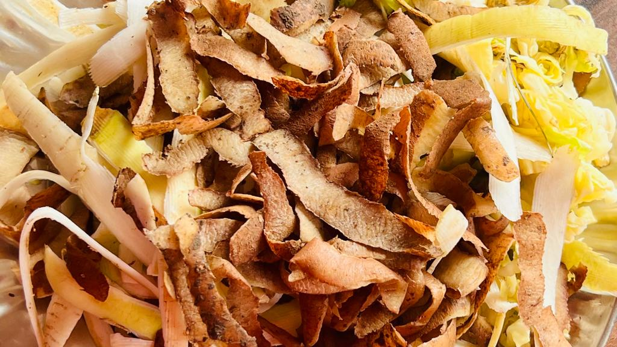

*Figure 3: Sample collection of kitchen waste*

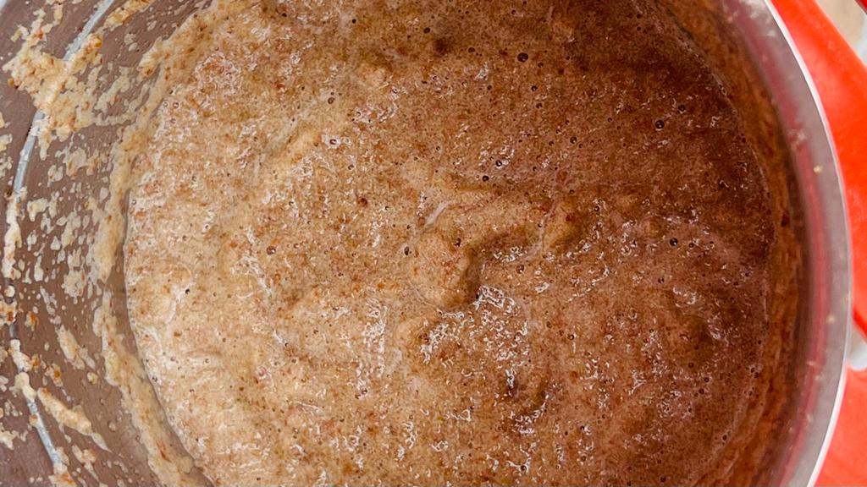

*Figure 4: Ground smooth paste of kitchen waste*

**3.2.2 Preparation of solution and design of experimental setup:**

**3.2.2.1 Preparation of 1 M KOH solution:**

About 280.55 gm of KOH was weighed. It was dissolved in distilled water in a beaker and then transferred to the gallon of 5 L containing distilled water.

**3.2.2.2 Preparation of inoculum:**

The ground and diluted kitchen waste was taken in a 100 mL beaker and it was allowed to incubate at 37 ˚C for three to four days.

**3.2.2.3 Preparation of 70% methanol solution:**

30 ml of distilled water was added to 70 ml of pure methanol in a 250 ml beaker to prepare 70 % methanol solution.

**3.2.2.4 Preparation of 70% acetone solution:**

30 ml of distilled water was added to 70 ml of pure acetone to prepare a 70 % acetone solution.

**3.2.2.5 Design of electrode:**

Scissors were used to cut the graphite sheet into 10 cm × 3 cm pieces. With the use of a needle and thread, these parts were joined to achieve the necessary thickness. The wire was inserted into it and wrapped utilizing the black tape.

**3.2.2.6 Activation of electrode:**

In a 250 ml beaker filled with a 70 % methanol solution, the graphite electrodes were immersed, and for 15 minutes, they were subjected to ultrasonication. The same procedure was repeated for 70 % acetone solution first and then in distilled water. After that, it was placed in the oven to dry for 15 to 20 minutes and finally kept in UV sonication for 15 minutes.

Graphite Felt Electrodes

Dipped in 70 % methanol and ultrasonicate for 15 minutes

Dipped in 70 % acetone and ultrasonicate for 15 minutes

Dipped in distilled water and ultrasonicate for 15 minutes

UV treatment for 15 minutes

*Figure 5: Flow chart for electrode activation*

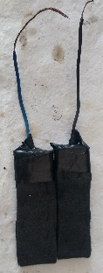 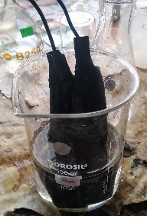 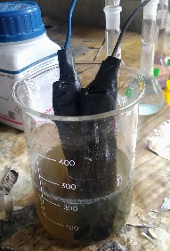

*Figure 6: Graphite electrode Figure 7: Graphite electrodes Figure 8: Graphite electrodes*

*before sonication after sonication*

**3.2.2.7 Sample preparation:**

For sample preparation, 100 gm of kitchen waste was weighed, ground, and diluted to 1000 ml with distilled water to achieve a 10 % dilution. With the aid of a funnel, it was poured into each of the jars. Each vessel received 4% inoculum. A pH meter was used to measure the pH of the samples both before and after the addition of 0.2% sodium bicarbonate. Then the final pH was maintained at 6.8. Similarly, 200 gm, 300 gm and 500 gm of sample was taken and the same procedure was repeated for 20 %, 30% and 50% dilutions respectively.

100 gm of sample was weighed and ground

Diluted to 1000 mL of distilled water

4% inoculum and 0.2% of sodium bicarbonate were added

Initial pH was measured and final pH 6.8 was maintained

*Figure 9: Flow chart showing sample preparation for 10 % dilution*

**3.2.2.8 Setup for gas production:**

One conical flask with electrodes was used as the test vessel and the other one served as the control vessel. With the use of a cork borer, three holes were made in the cork of the test vessel while just one hole was made in the cork of the control vessel. In the holes of the test vessel, two electrodes (anode and cathode) and an oxygen pipe were installed, whereas only an oxygen pipe was installed in the hole of the control vessel. These containers had the corks fixed and utilizing silicone, the holes were properly filled. Both vessels were sparged with nitrogen to keep an anaerobic environment inside of them and again necks of the jars were sealed using silicone and parafilm. The source of voltage employed was a potentiostat. It was wired with the assistance of metal clips.

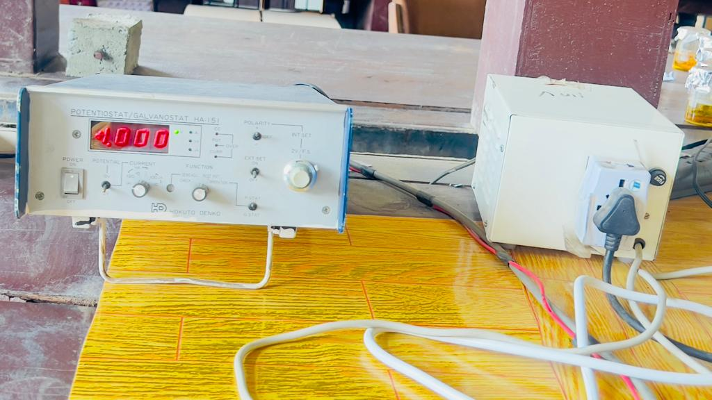

*Figure 10: Potentiostat*

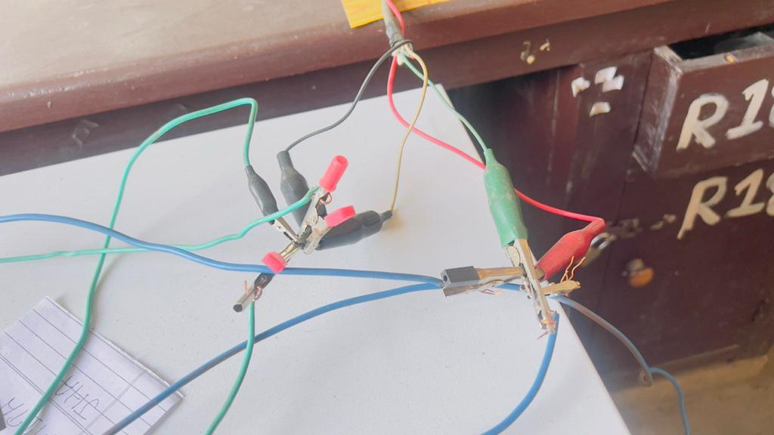

*Figure 11: Wire connections*

The test and control vessels were positioned within the oven. The measurement cylinders were filed next to the plastic tray that held the KOH solution. By using pipes in the vessels, the cylinders were only partially submerged in KOH to prevent gas leaks. It was all set up. By moving KOH downward, the gas that was produced was collected. The empty gas cylinders that the gas produced left behind were filled with KOH as needed. A similar procedure was done for dilution sets for 20%, 30%, and 50%. The whole setup was kept at 28 ˚C temperature for each arrangement and observed for 10 days.

Sample was prepared, diluted and pH was maintained at 6.8

Each diluted sample was poured equally into two jar vessels

Test vessel was provided with two electrodes (anode and cathode) and an oxygen pipe

Control vessel was provided with only oxygen pipes

Both the vessels were sparged with nitrogen to maintain an anaerobic condition

The vessels were sealed using silicone and parafilm to make vessels airtight

The setup was positioned inside the oven at temperature 28˚C and the inverted measuring cylinders and tray were filled with KOH

The electrodes were connected to the potentiostat with the help of wires and metal clips

The gas was collected by downward displacement and observed for 10 days

*Figure 12: Flow chart for experimental setup for gas production*

**3.2.3 Physical characterization of the sample:**

**3.2.3.1 pH measurement:**

The sample was diluted with distilled water to a proportion of 1:10 before it was permitted to stand for a period of thirty minutes. After agitating the sample for an entire hour a calibrated pH meter was employed to determine its pH.

**3.2.3.2 Moisture Content and TSS (AOAC, 2000):**

According to the American Society of Analytical Chemists 2000 technique, moisture content was measured by heating the sample at 105 ˚C overnight and was calculated using the following formulas.

% Total Suspended Solid (TSS) = (Dried sample weight/ fresh sample weight)

% Total Moisture = 1- TSS %

**3.2.3.3 Ash Content (AOAC, 2000):**

The dried sample used to calculate the moisture content was put in the crucible and weighed. These samples spent two hours in a muffle furnace at 550 ˚C. After the residue had cooled, the final weight was determined and the ash content and volatile suspended solid (VSS) were then computed.

% Ash Content = (weight of residue after heating/ weight of initial sample residue) ×100

% VSS = 1- % Ash content

**3.2.3.4 Determination of Chemical Oxygen Demand (COD):**

**3.2.3.4.1 Standard curve for COD:**

Hydrogen phthalate stock solution (1000mg/l) was made up. Then from the stock phthalate solution, a series of reference solutions ranging from 20mg/l to 900 mg/l were prepared. In a culture tube, 10 ml of the reference solution with water as the blank was prepared, and 6 ml of the digestion solution was added while completely mixing. Each tube was then filled with 14 ml of the catalyst solution the caps were secured and the layers were thoroughly mixed. After that culture tubes were placed in a hot air oven at 150˚C for two hours. After allowing the solution to cool, and precipitate to settle, absorption was measured at 600 nm with a blank for background correction.

**3.2.3.4.2 Determination of COD of sample:**

Similar to how the standard curve preparation was done 10ml of each sample was taken in a culture tube. The sample COD was then determined using a standard cure.

**3.2.3.5 Determination of Reducing Sugar:**

**3.2.3.5.1 Standard Curve for Reducing Sugar:**

Glucose stock solution (1000mg/l) was prepared. Then, a series of reference solutions from the stock glucose solution was prepared from 10mg/l to 480 mg/l. In a culture tube ml of the reference solution with water as the blank was prepared and the next step was to combine ml of each standard and blank with ml of DNS reagent in a culture tube. It was kept in boiling water for ten minutes after the DNS reagent was added. 3 ml of distilled water was then added after it was cooled. After that the standard was measured for absorbance at 540 nm and the background was corrected using a blank.

**3.2.3.5.2 Determination of reducing sugar of sample:**

3 mL of the sample and 1 mL of DNS were added. Then the same procedure was repeated as done for the calibration curve.

**3.2.3.6 Determination of phosphorus:**

1000 ml of the phosphorus stock solution and the working solution were prepared. Then from the working solution, a series of reference solutions ranging from 0.01 mg/l to 0.5 mg/l were prepared. The reference solutions were transferred to 100 ml Erlenmeyer flask and 8 ml of combined reagent was added to each of the flasks and were mixed thoroughly. Then the solutions were allowed to sit for 10-15 minutes for color development. The absorption was measured at 880 nm after the background collection with the blank solution.

**3.2.3.6.1 Determination of total phosphorus of sample:**

50 ml of the sample was transferred to a 100-ml Erlenmeyer flask and 1ml of the sulphuric acid solution was added. Then it was stirred and 0.4gm of ammonium persulfate was added. It was gently boiled on a hot plate for about 30 to 40 minutes to reach a final volume of around 10 mL. The sample was cooled and diluted to about 30ml and its pH was maintained at 7.0±0.2 by adding 1 mole of NaOH using a pH meter. And then it was diluted to about 50ml. 8ml of the combined reagent was added to the sample, thoroughly mixed background correction was done with a blank solution and absorbance was measured.

**3.2.3.6.2 Determination of hydrolyzable phosphorus of sample:**

50ml of sample was transferred to Erlenmeyer flask 1 ml of sulfuric acid solution was added and mixed. It was gently boiled on a preheated. Hot plate for approximately 30-40 minutes till a final volume of about 10ml was reached. The sample was cooled and diluted to about 80 ml and pH was adjusted to 7.0±0.2. Then it was diluted to 50ml. 8ml of combined reagent was added and thoroughly mixed. It was allowed to sit for 5 minutes for color development. The background correction was done with the blank solution and sample absorbance measurement procedures were followed.

**CHAPTER 4: RESULTS AND DISCUSSIONS**

**4.1: Physical Characterization of the sample:**

**4.1.1: pH of the sample:**

The pH of the sample can vary depending upon the composition of the kitchen waste. The pH of the sample was determined by using pH meter. The pH of the sample was found to be 5.86±0.05.

**4.1.2: Moisture content and TSS**:

The moisture content and TSS of the sample were determined by using the given formula:

% Total Suspended Solid (TSS) = (Dried sample weight/ fresh sample weight) ×100 %

= 6.71/50.28 ×100

= 13.34%

% Total Moisture = 1- TSS %

= (1- 0.1334)

= 86%

Hence, the TSS and total moisture in the sample were found to be 13.34% and 86% respectively.

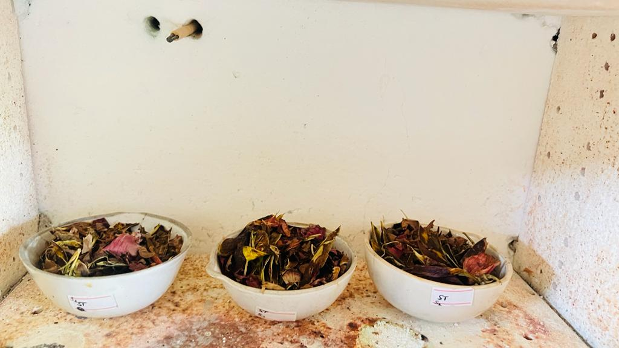

*Figure 13: Sample kept in oven for determination of moisture content*

**4.1.3: Ash Content (AOAC, 2000):**

The ash content and volatile suspended solid (VSS) were computed as,

% Ash Content = (weight of residue after heating/ weight of initial sample residue) ×100

= 0.527/6.71 ×100

= 7.85%

% VSS = 1- % Ash content

= 1-0.0785

= 92.15%

Hence, the ash content was found to be 7.85% and VSS was determined to be 92.15%.

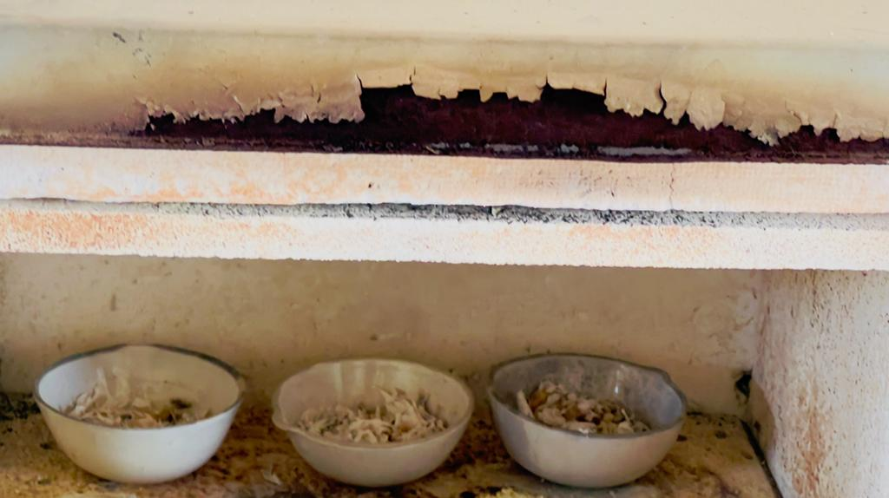 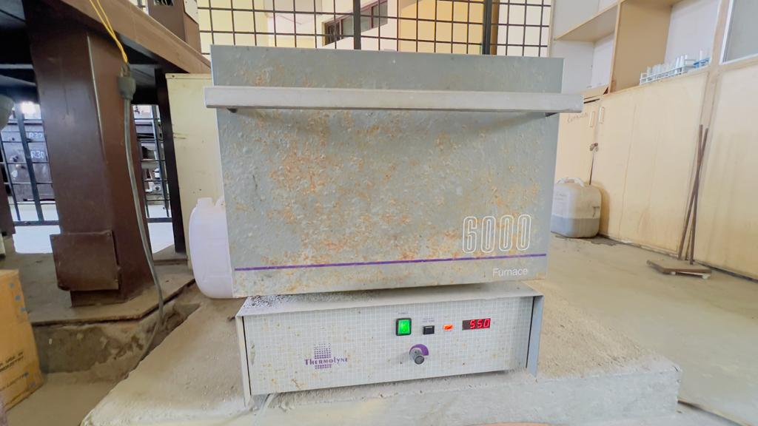

*Figure 14: Total ash obtained from the sample for Figure* *15: Muffle furnace*

*determination of ash content*

**4.1.4: Determination of chemical oxygen demand (COD):**

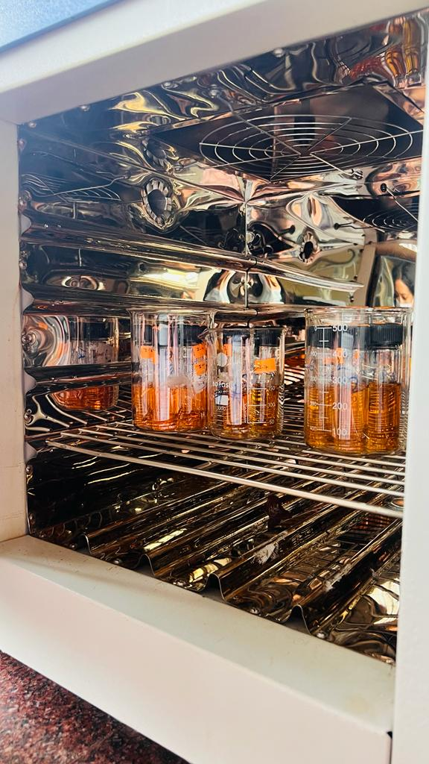

*Figure 16: Sample preparation for determination of COD of the sample*

The table and the graph for the standard calibration is shown below:

*Table 1: Absorbance Vs Concentration values for determination of standard curve of COD*

|  |  |
| --- | --- |
| Absorbance(Nm) | Concentration |
| 0 | 0 |
| 20 | 0.0011 |
| 50 | 0.0028 |
| 100 | 0.0031 |
| 200 | 0.0034 |
| 400 | 0.0086 |
| 600 | 0.0126 |
| 900 | 0.0134 |

*Figure 17: Plot of absorbance vs. concentration*

The graph for the standard calibration of COD is shown above. The equation was found to be 0.002x. The slope was determined and used to calculate the COD of the sample solution. The data obtained is shown in the table below:

*Table 2: Absorbance Vs Concentration values for determination of COD of sample*

|  |  |
| --- | --- |
| Sample | Absorbance(nm) |
| Before the experiment(Initial) | 0.2385 |
| After the experiment (test vessel) | 0.1834 |
| After the experiment (control vessel) | 0.1327 |

By using the slope obtained and absorbance, the concentration of COD was determined. The concentrations of COD were found to be 119.25 mg/mL, 91.7 mg/ml, and 66.35 mg/ml in the sample before the experiment, test vessel, and control vessel respectively.

**4.1.5: Determination of reducing sugar:**

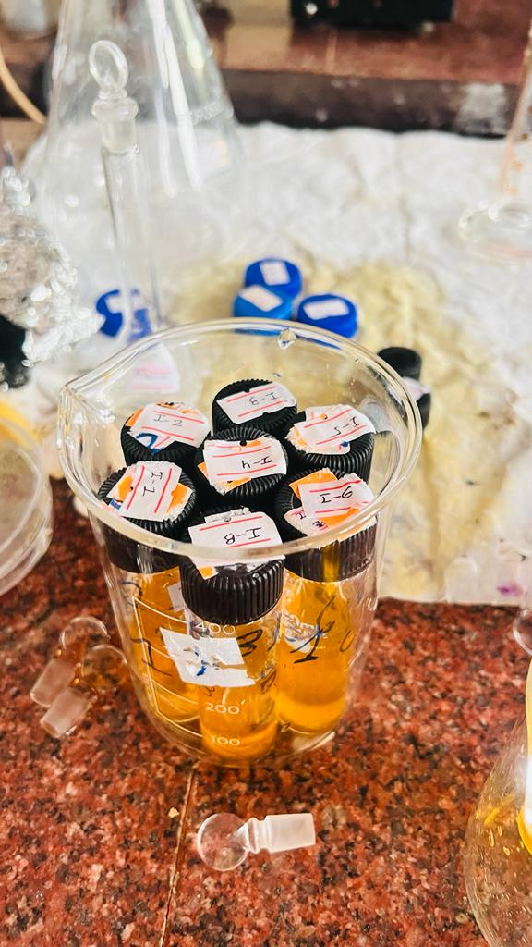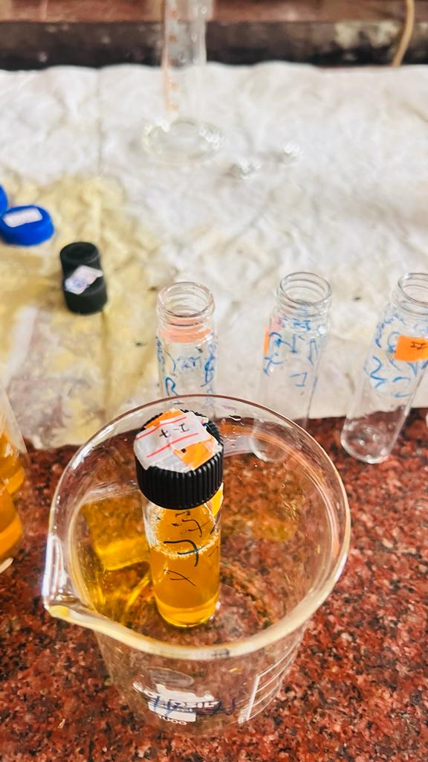

*Figure 18: sample preparation for determination of reducing sugar*

The table and graph standard calibration curve for reducing sugar is given below:

*Table 3: Absorbance Vs Concentration values for determination of standard calibration curve for reducing sugar*

|  |  |
| --- | --- |
| Concentration | Absorbance |
| 0 | 0 |
| 10 | 0.099 |
| 20 | 0.0935 |
| 40 | 0.0319 |
| 60 | 0.0826 |
| 120 | 0.2419 |
| 240 | 0.3981 |
| 480 | 1.8395 |

*Figure 19: Plot of absorbance vs. concentration*

The graph for the standard calibration of reducing sugar is shown above. The equation was found to be 0.0033x. The slope was determined and used to calculate the reducing sugar of the sample solution. The data obtained is shown in the table below:

*Table 4: Absorbance Vs Concentration values for determination of reducing sugar of the sample*

|  |  |
| --- | --- |
| Sample | Absorbance(nm) |
| Before the experiment(Initial) | 0.2385 |
| After the experiment (test vessel) | 0.1834 |
| After the experiment (control vessel) | 0.1327 |

By using the slope obtained and absorbance, the concentration of reducing sugar was determined. The concentrations of reducing sugar were found to be 72.273 mg/ml, 55.576 mg/ml, and 40.212 mg/ml respectively.

**4.1.7: Determination of phosphorus:**

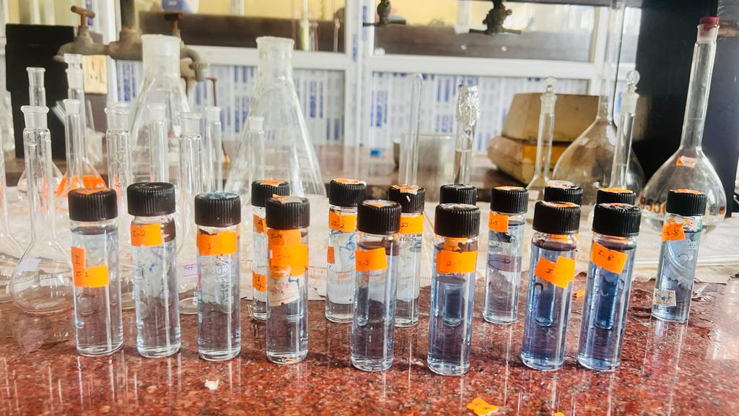

*Figure 20: Preparation of solution for determination of phosphorus in the sample*

The table and graph standard calibration curve for phosphorus is given below:

*Table 5: Absorbance Vs Concentration values for determination of standard calibration curve for the phosphorus*

|  |  |
| --- | --- |
| Concentration | Absorbance |
| 0 | 0 |
| 0.01 | 0.2305 |
| 0.03 | 0.2333 |
| 0.05 | 0.2541 |
| 0.1 | 0.2645 |
| 0.2 | 0.2717 |
| 0.3 | 0.3013 |
| 0.4 | 0.3546 |
| 0.5 | 0.3784 |

*Figure 21: Plot of absorbance vs. concentration*

The graph for the standard calibration of phosphorus is shown above. The equation was found to be 0.95x. The slope was determined and used to calculate the phosphorus of the sample solution. The data obtained is shown in the table below:

*Table 6: Absorbance Vs Concentration values for determination of phosphorus of the sample*

|  |  |
| --- | --- |
| Sample | Absorbance(nm) |
| Before the experiment(Initial) for total phosphorus | 1.3508 |
| Before the experiment(Initial) for hydrolyzable phosphorus | 1.191 |

By using the slope obtained and absorbance, the concentration of total phosphorus was determined. The concentrations of total phosphorus and hydrolyzable phosphorus were found to be 1.4218 mg/ml and 1.2537 mg/ml respectively.

**4.2: Cumulative biogas production:**

In the experiments, two vessels were employed; one was designated as the test vessel and the other as the control vessel. To give the proper voltage, the test vessel was connected to the potentiostat, but the control vessel was not. The substrate for methane production was kitchen waste. As electrodes, graphite felts were employed. The source of the bacterial growth that fueled methanogenesis was the inoculum that was added to the sample. NaHCO3 was added for the sterilization and to keep the pH constant for a long time because the bacterial reaction lowers it. To ensure that any CO2 generated would precipitate and settle at the bottom of the cylinder, KOH solution was used in place of water. Ten days were spent observing each set. KOH was moved below to collect the gas that had formed. The KOH solution in the cylinder would be displaced by the gas produced. Once the cylinder was empty, then it was refilled. The tables and graph below show the experiments findings.

**4.2.1: Production of bio gas at various dilution concentrations:**

**4.2.1.1: 10% dilution of kitchen waste solution for bio gas production:**

100gm of the kitchen waste was placed in each of two 1000ml flasks to create a 10% kitchen waste solution. The electrical supply was connected to the test vessel. The oven was set to 28˚C with booth vessels inside. 10 days were observed for the gas production.

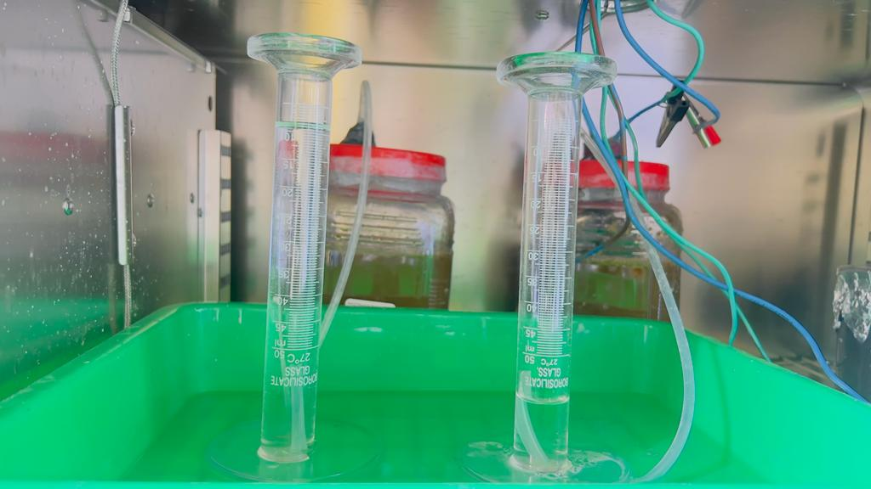 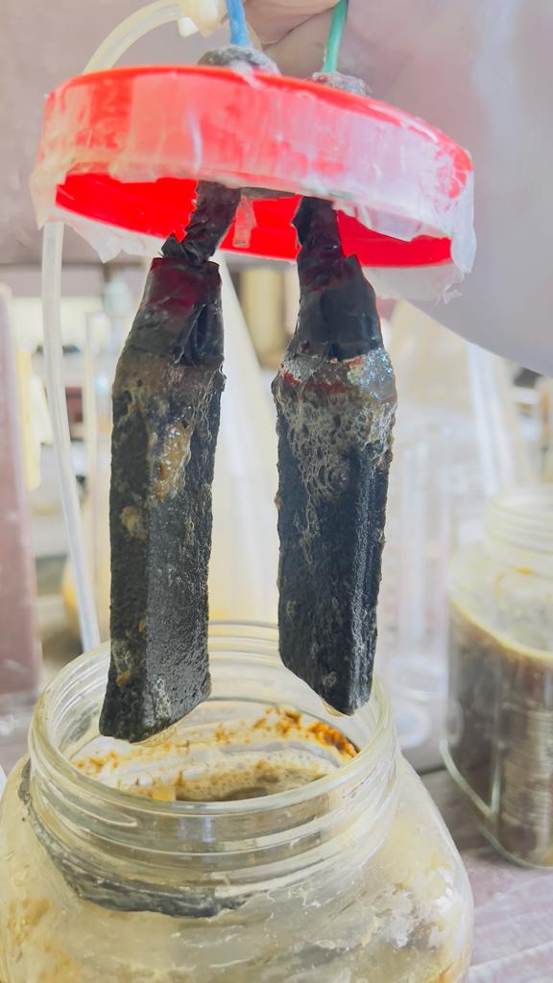  *Figure 22: Setup for 10 % dilution for biogas production Figure 23: Growth of bacteria*

The table below shows the cumulative gas production in the respective vessels.

*Table 7: Cumulative biogas formed Vs Days values for 10 % dilution*

|  |  |  |
| --- | --- | --- |
| No of days | The volume of gas produced in the Test vessel(ml) | The volume of gas produced in the control vessel(ml.) |
| 1 | 0 | 0 |
| 2 | 0 | 0 |
| 3 | 0 | 0 |
| 4 | 22 | 9 |
| 5 | 118 | 23 |
| 6 | 239 | 44 |
| 7 | 402 | 94 |
| 8 | 516 | 144 |
| 9 | 566 | 186 |
| 10 | 566 | 187 |

*Table 8: pH of the sample before and after experiments for 10 % dilution*

|  |  |  |
| --- | --- | --- |
| The pH of the sample solution | Before the experiment | After the experiment |
| Test vessel | 5.85 | 4.59 |
| Control vessel | 5.91 | 4.80 |

From the table, it was determined that the total amount of gas generated in the test vessel was 566 ml, compared to 187 ml in the control vessel. To conclude, the gas produced in the test vessel was greater than that produced in the control vessel. Prior to the experiment, the pH of the solution was kept at 6.8 in both the test and control vessels. Following the experiment, it was discovered that the pH of the test vessel had dropped to 4.59, whereas the pH of the control vessel had dropped to 4.80. Given the 10% dilution of kitchen waste solution, the volume of KOH replaced by the biogas generated is illustrated below:

*Figure 24: Plot of volume of KOH displaced vs No. of days for 10% dilution*

**4.2.1.2: 20% dilution of kitchen waste solution for biogas production:**

200 gm of the kitchen waste was placed in each of two 1000ml conical flasks to create a 20% kitchen waste solution. The electrical supply was connected to the test vessel. The oven was set to 28˚C with both vessels inside. 10 days were observed for the gas production.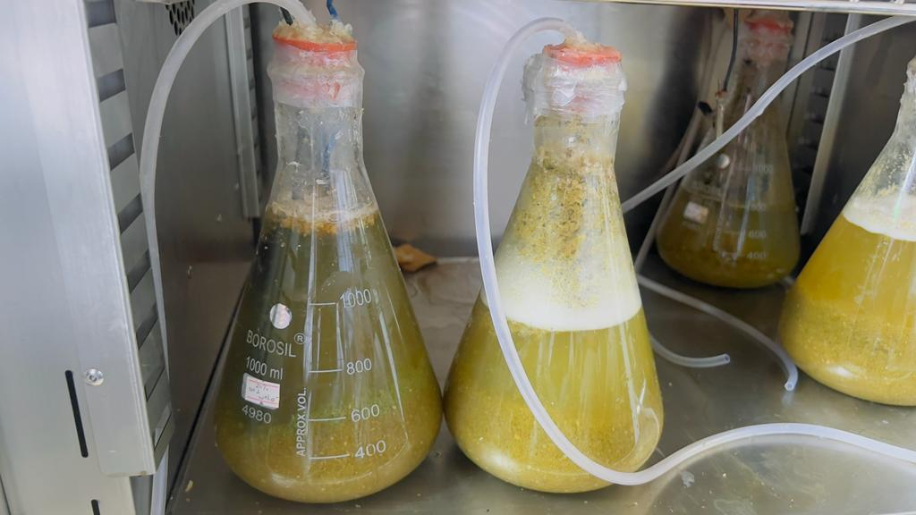

*Figure 25: Sample solution for 20 % dilution*

*Table 9: Cumulative biogas formed Vs Days values for 20 % dilution*

|  |  |  |
| --- | --- | --- |
| No. of days | The volume of gas produced in the Test vessel (mL) | The volume of gas produced in the Control Vessel (mL) |
| 1 | 0 | 0 |
| 2 | 0 | 0 |
| 3 | 0 | 0 |
| 4 | 23 | 18 |
| 5 | 92 | 37 |
| 6 | 154 | 87 |
| 7 | 272 | 132 |
| 8 | 340 | 164 |
| 9 | 390 | 172 |
| 10 | 412 | 198 |

*Table 10: pH of the sample before and after experiments for 20 % dilution*

|  |  |  |
| --- | --- | --- |
| The pH of the sample solution | Before the experiment | After the experiment |
| Test vessel | 5.77 | 4.64 |
| Control vessel | 5.98 | 4.88 |

From the table, it was determined that the total amount of gas generated in the test vessel was 412 ml, compared to 198 ml in the control vessel. To conclude, the gas produced in the test vessel was greater than that produced in the control vessel. Prior to the experiment, the pH of the solution was kept at 6.8 in both the test and control vessels. Following the experiment, it was discovered that the pH of the test vessel had dropped to 4.64, whereas the pH of the control vessel had dropped to 4.88. Given the 20% dilution of kitchen waste solution, the volume of KOH replaced by the biogas generated is illustrated below:

*Figure 26: Plot of the volume of KOH displaced vs No. of days for 20 % dilution*

**4.2.1.3: 30% dilution of kitchen waste solution for biogas production**

300gm of the kitchen waste was placed in each of two 1000ml conical flasks to create a 30% kitchen waste solution. The electrical supply was connected to the test vessel. The oven was set to 28˚C with both vessels inside. 10 days were observed for the gas production.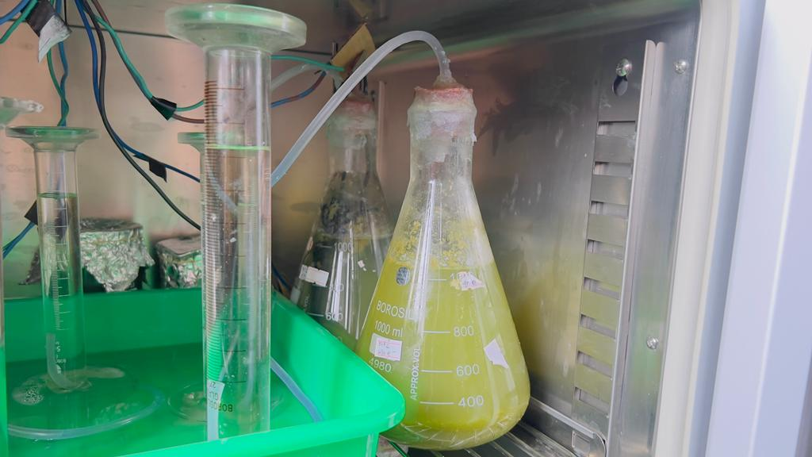

*Figure 27: Setup for 30 % dilution for production of biogas*

*Table 11: Cumulative biogas formed Vs Days values for 30 % dilution*

|  |  |  |
| --- | --- | --- |
| No. of days | The volume of gas produced in the Test vessel (mL) | The volume of gas produced in the Control Vessel (mL) |
| 1 | 0 | 0 |
| 2 | 0 | 0 |
| 3 | 0 | 0 |
| 4 | 50 | 35 |
| 5 | 114 | 76 |
| 6 | 202 | 106 |
| 7 | 348 | 156 |
| 8 | 452 | 209 |
| 9 | 488 | 235 |
| 10 | 506 | 266 |

*Table 12: pH of the sample before and after experiments for 20 % dilution*

|  |  |  |
| --- | --- | --- |
| The pH of the sample solution | Before the experiment | After the experiment |
| Test vessel | 6.03 | 4.86 |
| Control vessel | 6.13 | 5.03 |

From the table, it was determined that the total amount of gas generated in the test vessel was 506 ml, compared to 266 ml in the control vessel. To conclude, the gas produced in the test vessel was greater than that produced in the control vessel. Prior to the experiment, the pH of the solution was kept at 6.8 in both the test and control vessels. Following the experiment, it was discovered that the pH of the test vessel had dropped to 4.59, whereas the pH of the control vessel had dropped to 4.80. Given the 10% dilution of kitchen waste solution, the volume of KOH replaced by the biogas generated is illustrated below:

*Figure 28: Plot of volume of KOH displaced vs No. of days for 30% dilution*

**4.2.1.4: 50% dilution of kitchen waste solution for biogas production:**

500gm of the kitchen waste was placed in each of two 1000ml conical flasks to create a 50% kitchen waste solution. The electrical supply was connected to the test vessel. The oven was set to 28˚C with both vessels inside. 10 days were observed for the gas production.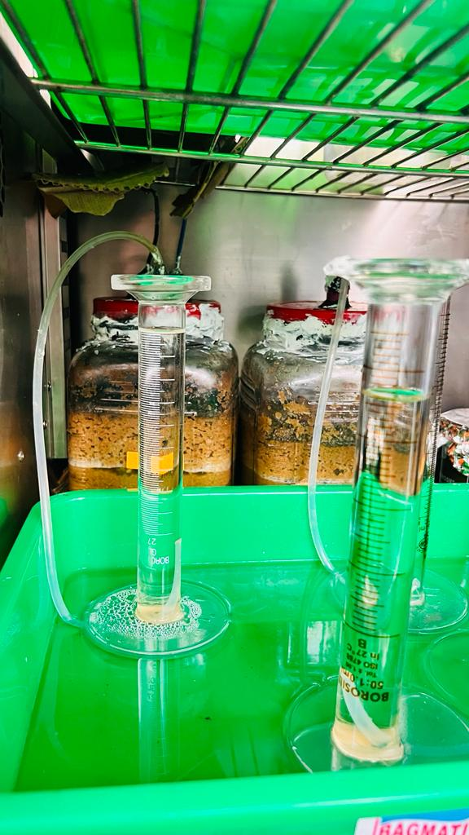 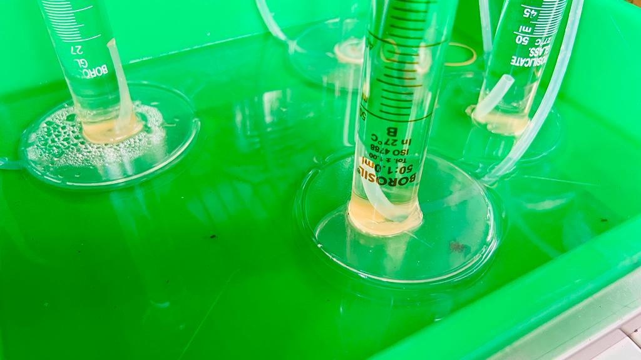

*Figure 29: Setup for 50 % dilution for biogas production Figure 30: Formation of precipitate during experiment*

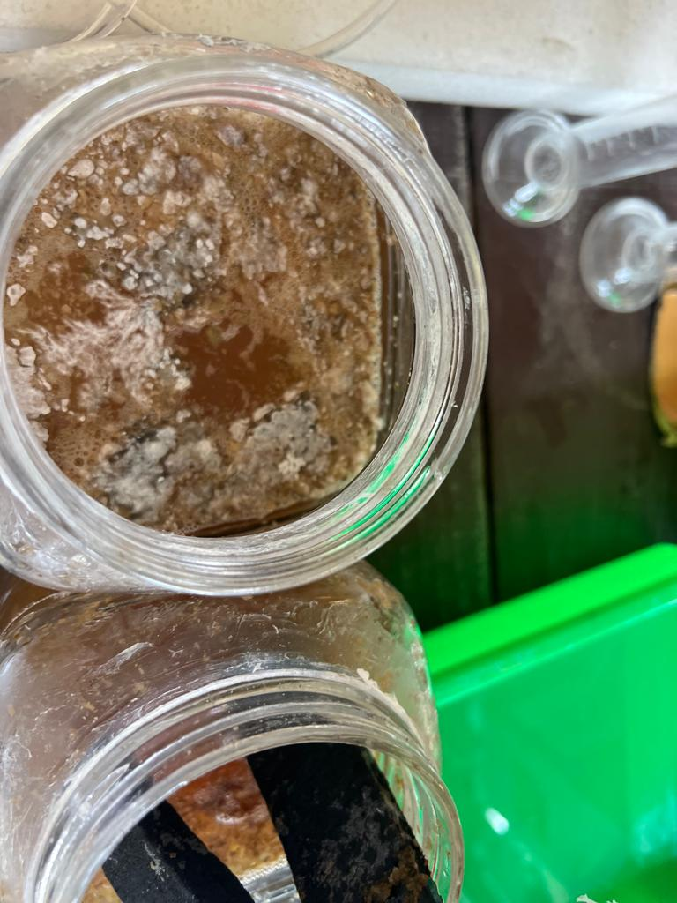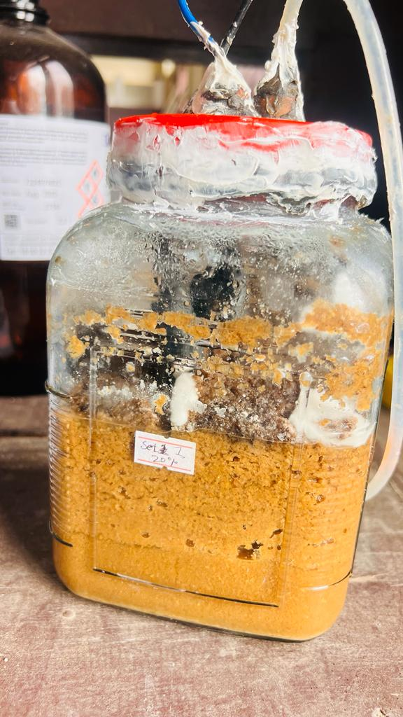

*Figure 31: Figure showing the growth of bacteria in the feed*

*Table 13: Cumulative biogas formed Vs Days values for 50 % dilution*

|  |  |  |
| --- | --- | --- |
| No. of days | The volume of gas produced in the Test vessel (mL) | The volume of gas produced in the Control Vessel (mL) |
| 1 | 0 | 0 |
| 2 | 0 | 0 |
| 3 | 0 | 0 |
| 4 | 44 | 36 |
| 5 | 142 | 83 |
| 6 | 227 | 125 |
| 7 | 270 | 173 |
| 8 | 364 | 220 |
| 9 | 452 | 262 |
| 10 | 496 | 302 |

*Table 14: pH of the sample before and after experiments for 50 % dilution*

|  |  |  |
| --- | --- | --- |
| The pH of the sample solution | Before the experiment | After the experiment |
| Test vessel | 5.79 | 4.83 |
| Control vessel | 5.68 | 5.19 |

From the table, it was determined that the total amount of gas generated in the test vessel was 496 ml, compared to 302 ml in the control vessel. To conclude, the gas produced in the test vessel was greater than that produced in the control vessel. Prior to the experiment, the pH of the solution was kept at 6.8 in both the test and control vessels. Following the experiment, it was discovered that the pH of the test vessel had dropped to 4.9, whereas the pH of the control vessel had dropped to 4.80. Given the 10% dilution of kitchen waste solution, the volume of KOH replaced by the biogas generated is illustrated below:

*Figure 32: Plot of the volume of KOH displaced vs. No. of days for 50% dilution*

**4.2: Graphical representation for comparison of biogas formed at different dilutions:**

*Figure 33: Plot of cumulative biogas formed at different dilutions*

The graphical representation for the comparison of biogas produced at different dilution is shown in the above figure. It is clear that for all the dilutions, the test vessel produced more biogas than the control one. Similarly, the biogas produced was highest in 10 % dilution and the least in 20 % dilution.

**CHAPTER 5: CONCLUSION**

The experiment revealed that MES increases the amount of methane production in the biogas. More gas was produced in the test vessel than in the control vessel in every series of dilutions. Consequently, MES is found to be a successful technology for upgrading biogas. 10 % dilution was shown to be more effective for producing biogas during the sequence of solutions used in the experiment. The most quantity of gas was created in 10 % dilution and the least amount in 20 % dilution. COD was discovered to be 119.25 mg/mL prior to the experiment and 91.7 mg/ml and 66.35 mg/ml following it. It demonstrates that COD declines after the experiment, however, sample in the test vessel showed COD more value than in control vessel. Similarly, reducing sugar before the experiment was determined to be 72.273 mg/ml and 55.576 mg/ml and 40.212 mg/ml and in the sample of test vessel and control vessels respectively. Likewise the total phosphorus contained in the sample was found to be 1.4218 mg/ml and the hydrolyzable phosphorus was found to be 1.2537 mg/ml respectively.

**CHAPTER 6: RECOMMENDATION**

Based on yield and process efficiency, this research work is further recommended for different types of industries for future improvement, production, and/or policy implementation. In further research, it is advised to recirculate the sample in anode for improvements in the gas yield. This research may be useful to many waste management industries and for electricity production. It can be useful for industrial applications also after the scaling up of this technique. Further research needs to be done for the improvement of this technique and the gas yields. Special attention should be given to the design of the reactors for the effective implementation of MES.

**REFERENCES:**

Abdel-Shafy, H.I.; Mansour, M.S. Solid waste issue: Sources, composition, disposal, recycling, and valorization. *Egypt. J. Petrol.* **2018**, *27*, 1275–1290

Abrevaya, X. C., Sacco, N. J., Bonetto, M. C., Hilding-Ohlsson, A., & Cortón, E. (2015). Analytical applications of microbial fuel cells. Part II: Toxicity, microbial activity and quantification, single analyte detection and other uses. Biosensors and Bioelectronics, 63, 591–601.

Alam, P.; Ahmade, K. Impact of Solid Waste on Health and The Environment. *Int. J. Sustain. Dev. Green Econ.* **2013**, *2*, 165–168.

Aruna, G.; Kavitha, B.; Subashini, N.; Indira, S. An observational study on practices of disposal of waste Garbage in Kamakshi Nagar at Nellore. *Int. J. Appl. Res.* **2018**, *4*, 392–394.

Bhat, R.A.; Dar, S.A.; Dar, D.A.; Dar, G. Municipal Solid Waste Generation and Current Scenario of its Management in India. *Int. J. Adv. Res. Sci. Eng.* **2018**, *7*, 419–431.

Blesson, S., Ashok, A., Raghavan, A., Gunagi, D. P., Jeppu, G., & Rashmishree, K. N. (2016). Production of biogas using kitchen waste. *International Journal of Research in Engineering and Technology*, *5*(6), 304-308.

Cerrillo, M.; Burgos, L.; Bonmatí, A. Biogas Upgrading and Ammonia Recovery from Livestock Manure Digestates in a Combined Electromethanogenic Biocathode—Hydrophobic Membrane System. *Energies* **2021**, *14*, 503.

Chen, Y., Yang, D., Liu, R., Li, L., Liu, H., Dai, X., & Chen, Y. (2023). Thermophilic anaerobic digestion of kitchen waste driven by microbial electrolysis cell (MEC): Digestion performances, anodic microorganisms’ distribution and current utilization efficiency. *Energy Conversion and Management*, *279*, 116747.

Das, P., Banerjee, S., & Das, N. C. (2022). Polymer-graphene composite in aerospace engineering. In *Polymer Nanocomposites Containing Graphene* (pp. 683-711). Woodhead Publishing.

Dumas, C., Mollica, A., Féron, D., Basséguy, R., Etcheverry, L., & Bergel, A. (2007). Marine microbial fuel cell: use of stainless steel electrodes as anode and cathode materials. *Electrochimica acta*, *53*(2), 468-473.

Feng, Q., Song, Y. C., & Ahn, Y. (2018). Electroactive microorganisms in bulk solution contribute significantly to methane production in bioelectrochemical anaerobic reactors. *Bioresource technology*, *259*, 119-127

Guo, K., Prévoteau, A., Patil, S. A., & Rabaey, K. (2015). Engineering electrodes for microbial electrocatalysis. *Current opinion in biotechnology*, *33*, 149-156.

Horváth-Gönczi, N. N., Bagi, Z., Szuhaj, M., Rákhely, G., & Kovács, K. L. (2023). Bioelectrochemical Systems (BES) for Biomethane Production. *Fermentation*, *9*(7), 610.

Huang, J., Feng, H., Huang, L., Ying, X., Shen, D., Chen, T., & Xu, Y. (2020). Continuous hydrogen production from food waste by anaerobic digestion (AD) coupled single-chamber microbial electrolysis cell (MEC) under negative pressure. *Waste Management*, *103*, 61-66.

Huang, L., Wang, Q., Jiang, L., Zhou, P., Quan, X., & Logan, B. E. (2015). Adaptively evolving bacterial communities for complete and selective reduction of Cr (VI), Cu (II), and Cd (II) in biocathode bioelectrochemical systems. Environmental Science & Technology, 49(16), 9914–9924.

Irfan, M., Bai, Y., Zhou, L., Kazmi, M., Yuan, S., Maurice Mbadinga, S., et al. (2019). Direct microbial transformation of carbon dioxide to value-added chemicals: A comprehensive analysis and application potentials. Bioresource Technology, 288, 121401. [https://doi.org/10.1016/j. biortech.2019.121401](https://doi.org/10.1016/j.%20biortech.2019.121401)

Ivase, Tertsegha J-P.; Nyakuma, Bemgba B.; Oladokun, Olagoke; Abu, Peter T.; Hassan, Muhammed N. (2019). *Review of the Principal Mechanisms, Prospects and Challenges of Bioelectrochemical Systems. Environmental Progress & Sustainable Energy, (), e13298.* doi:10.1002/ep.132Liu, C., Xiao, J., Li, H., Chen, Q., Sun, D., Cheng, X., & Holmes, D. E. (2021). High efficiency in-situ biogas upgrading in a bioelectrochemical system with low energy input. *Water Research*, *197*, 117055.

Kaewdiew, J., Ramaraj, R., Koonaphapdeelert, S., & Dussadee, N. (2019). Assessment of the biogas potential from agricultural waste in northern Thailand. *Maejo International Journal of Energy and Environmental Communication*, *1*(1), 40-47.

Lee, M. E., Ahn, Y., Shin, S. G., & Chung, J. W. (2022). Enhancement of Biogas Production in Anaerobic Digestion Using Microbial Electrolysis Cell Seed Sludge. *Energies*, *15*(19), 7042.

Liu, C., Yuan, X., Gu, Y., Chen, H., Sun, D., Li, P., & Holmes, D. E. (2020). Enhancement of bioelectrochemical CO2 reduction with a carbon brush electrode via direct electron transfer. *ACS Sustainable Chemistry & Engineering*, *8*(30), 11368-11375.

Manonmani, P., Muazu, L., Kamaraj, M. C., Goel, M., & Elangomathavan, R. (2017). Biogas production potential of food waste. *International Journal of Environment, Agriculture and Biotechnology*, *2*(2), 238720.

Mohamed Ali, A., Alam, M. Z., Mohamed Abdoul-latif, F., Jami, M. S., Gamiye Bouh, I., Adebayo Bello, I., & Ainane, T. (2023). Production of Biogas from Food Waste Using the Anaerobic Digestion Process with Biofilm-Based Pretreatment. *Processes*, *11*(3), 655.

Naradasu, D., Long, X., Okamoto, A., & Miran, W. (2020). Bioelectrochemical systems: principles and applications. *Bioelectrochemical Systems: Vol. 1 Principles and Processes*, 1-33.

Ogwueleka, T.C. Municipal solid waste characteristics and management in Nigeria. *Iran. J. Environ. Health Sci. Eng.* **2009**, *6*, 173–180.

OjikutuAbimbola, O., & Osokoya Olumide, O. (2014). Evaluation of biogas production from food waste. *IJES*, *3*(1), 01-07.

Pant, D., Singh, A., Van Bogaert, G., Olsen, S. I., Nigam, P. S., Diels, L., & Vanbroekhoven, K. (2012). Bioelectrochemical systems (BES) for sustainable energy production and product recovery from organic wastes and industrial wastewaters. *Rsc Advances*, *2*(4), 1248-1263.

Park, J., Lee, B., Tian, D., & Jun, H. (2018). Bioelectrochemical enhancement of methane production from highly concentrated food waste in a combined anaerobic digester and microbial electrolysis cell. *Bioresource technology*, *247*, 226-233.

Pasternak, G., Greenman, J., & Ieropoulos, I. (2017). Self-powered, autonomous biological oxygen demand biosensor for online water quality monitoring. Sensors and Actuators B: Chemical, 244, 815–822.

Pierson, H. O. (1993). Graphite structure and properties. *Handbook of carbon, graphite, diamonds and fullerenes*, 43-69.

Prajapati, K. B., & Singh, R. (2020). Enhancement of biogas production in bio-electrochemical digester from agricultural waste mixed with wastewater. *Renewable Energy*, *146*, 460-468.

Rabaey, K., Angenent, L., Schroder, U., & Keller, J. (Eds.). (2009). *Bioelectrochemical systems*.

Rahman, M. A., Shahazi, R., Nova, S. N. B., Uddin, M. R., Hossain, M. S., & Yousuf, A. (2023). Biogas production from anaerobic co-digestion using kitchen waste and poultry manure as substrate—part 1: substrate ratio and effect of temperature. *Biomass conversion and biorefinery*, *13*(8), 6635-6645.

Ray, N. H. S., Mohanty, M. K., & Mohanty, R. C. Biogas Production from Kitchen Wastes: A Source of Renewable Energy.

Sangeetha, T., Guo, Z., Liu, W., Cui, M., Yang, C., Wang, L., & Wang, A. (2016). Cathode material as an influencing factor on beer wastewater treatment and methane production in a novel integrated upflow microbial electrolysis cell (Upflow-MEC). *International Journal of Hydrogen Energy*, *41*(4), 2189-2196.

Siegert, M., Yates, M. D., Call, D. F., Zhu, X., Spormann, A., & Logan, B. E. (2014). Comparison of nonprecious metal cathode materials for methane production by electromethanogenesis. *ACS sustainable chemistry & engineering*, *2*(4), 910-917.

Wang, D.; Tang, Y.-T.; Long, G.; Higgitt, D.; He, J.; Robinson, D. Future improvements on performance of an EU landfill directive driven municipal solid waste management for a city in England. *Waste Manag.* **2020**, *102*, 452–463.

Xu, X., Chen, C., Wang, A., Guo, W., Zhou, X., Lee, D. J., et al. (2014). Simultaneous removal of sulfide, nitrate and acetate under denitrifying sulfide removal condition: modeling and experimental validation. Journal of Hazardous Materials, 264, 16–24.

Zeppilli, M., Simoni, M., Paiano, P., & Majone, M. (2019). Two-side cathode microbial electrolysis cell for nutrient recovery and biogas upgrading. *Chemical Engineering Journal*, *370*, 466-476.

Zhao, L., Wang, X. T., Chen, K. Y., Wang, Z. H., Xu, X. J., Zhou, X., ... & Chen, C. (2021). The underlying mechanism of enhanced methane production using microbial electrolysis cell assisted anaerobic digestion (MEC-AD) of proteins. *Water Research*, *201*, 117325.

Zhu, L., Cheng, K. Enhanced biogas production efficiency of kitchen waste by anaerobic co-digestion and pretreatment. *Biomass Conv. Bioref*. (2023).https://doi.org/10.1007/s13399-023-04672-1.

Zhuang, L., Yuan, Y., Wang, Y., & Zhou, S. (2012). Long-term evaluation of a 10-liter serpentinetype microbial fuel cell stack treating brewery wastewater. Bioresource Technology, 123, 406–412.

Ziauddin, Z., & Rajesh, P. (2015). Production and analysis of biogas from kitchen waste. *İnternational research journal of engineering and technology*, *2*(4), 622-632.